SECURITIES AND EXCHANGE COMMISSION

Washington, DC 20549

_________________

FORM 6-K

Report of Foreign Issuer

Pursuant to Rule 13a-16 or 15d-16

of the Securities Exchange Act of 1934

July 22, 2003

REUTERS GROUP PLC

(Translation of registrant’s name into English)

85 FLEET STREET, LONDON EC4P 4AJ, ENGLAND

(Address of principal executive offices)

[Indicate by check mark whether the registrant files or will file annual reports under cover of Form 20-F or Form 40-F.]

Form 20-F X Form 40-F __

[Indicate by check mark whether the registrant by furnishing the information contained in this Form is also thereby furnishing the information to the Commission pursuant to Rule 12g3-2(b) under the Securities Exchange Act of 1934.]

Yes __ No X

SIGNATURES

Pursuant to the requirements of the Securities Exchange Act of 1934, the registrant has duly caused this report to be signed on its behalf by the undersigned, thereunto duly authorized.

REUTERS GROUP PLC

(Registrant)

Dated: July 30, 2003 By:/s/ Nancy C. Gardner

ARCHIVED PRESENTATION

This presentation may include forward-looking statements. The Risk Factors section of Reuters 2002 Annual Report and Form 20-F describes certain important factors that could cause actual results to differ materially from those in our forward-looking statements today. You can obtain copies of our Annual Report from Reuters website or from our Investor Relations offices in London and New York.

Reuters

Interim Results

London

Tuesday 22 July 2003

David Grigson, Finance Director: Good morning. Before getting to the numbers, I will make some introductory remarks. I will just remind you of a couple of conventions that run consistently through my presentation, just as they have done on previous occasions.

The first is that the word ‘normalise’, when applied to profits or earnings, means that we have adjusted these to exclude amortisation, impairment charges and gains and losses on disposals. Where I have used the word ‘underlying’ to describe a growth rate, the calculation excludes the effect of all currency movements and the impact of acquisitions and disposals. There is one exception to this rule, which is in Instinet, where it is now impossible to split out from the Instinet numbers or in the Instinet numbers, the Island business that was acquired last year, because the two businesses have been fully and now inseparably integrated.

That said, let me turn to the financial headlines for the first half of 2003.

Financial headlines

In Reuters, the headlines are these. First, our revenue was down 12% on an underlying basis, with recurring revenue down 10%. Second quarter recurring revenue was down 10.9%, in line with our 11% guidance in April. We have achieved a normalised operating margin, pre-restructuring, of 14.7% in the first six months, which compares to 12.6% last time.

As you will see, currency movements have been helpful to our margin performance, but most of the improvement is down to the continuing focus, including the acceleration of Fast Forward, on managing our costs down at a rate faster than the decline in our revenues. Normalised PBT in Reuters is up 97%, while normalised earnings per share is up 125%. The strong focus on cash management is demonstrated in a 12-month rolling profits into cash conversion number of 110%. Finally, we have maintained the interim dividend at 3.85p.

Instinet, who reported yesterday, have also made good progress on the cost side, whilst experiencing generally better trading conditions in the second quarter than they had seen earlier in the year. On a UK GAAP basis, this translates into a second quarter revenue performance which showed an 11% improvement over the first quarter, pre-restructuring again, moving from a loss of £5 million in the first half of 2002 to a profit of £4 million this time.

Finally, at a Group level, we have reported a normalised pre-tax profit of £87 million, compared with a small loss last year.

Reuters – financial performance

Let us get into the numbers in more detail. I will start by looking at Reuters and move on to Instinet, and then pull together the Group numbers.

Revenue in Reuters is down 13% at £1.35 billion. On an underlying basis, which in this half year means excluding currency effects and the impact of the Multex acquisition, revenue was down 12%. Exchange rate fluctuations have had a material effect on our results this half. With 39% of our revenue denominated in US dollars, the movement in the dollar/sterling exchange rate contributed 4% to our actual revenue decline this half. This has been partially balanced by a stronger euro, such that the net impact of currency movement has been to push 2003 first half revenue 1.4% lower.

Our operating costs, pre-restructuring, are down 15% on an overall basis, and down 13% on an underlying basis, with currency movements again being the main driver of the difference. Reuters normalised operating profit is up 2%, before the impact of restructuring charges. The normalised operating margin on this basis increased to 14.7%, compared to 12.6% last year.

As our profits are heavily skewed towards the euro, the appreciation in that currency year to year has boosted our pre-restructuring operating profit by 9% and added a full 1% to our first half operating margin. We have taken a £79 million restructuring charge this year, all of which relates to early actions taken as part of the Fast Forward programme to reduce headcount and get our occupancy costs down. Tom will say more about the good start we have made in delivering Fast Forward benefits in his part of the presentation.

Moving on, Reuters share of losses from joint ventures and affiliates was down to £13 million from £30 million last time. Having successfully shortened the list of associate companies in recent times, these losses are now being incurred on the three principal portfolio companies of Factiva, Radianz and TIBCO. Good cost control contributed to improved trading performance in Factiva and TIBCO, while Radianz continues to benefit from good growth in the third party extranet revenue. In addition, our share of TIBCO’s losses last year included some £11 million of one-off restructuring charges.

Interest costs in Reuters were down £4 million to £14 million, reflecting the receipt of the special dividend from Instinet last October. The combination of all these moving parts resulted in a near doubling of normalised pre-tax profit in Reuters to £92 million. Below pre-tax profit, the normalised tax rate for the first half was 25%, which is the rate we expect to apply for the full year. Finally, normalised earnings per share was 4.9p, and we have declared an interim dividend of 3.85p, the same as last year.

Reuters – revenue by type

Let us go on and look at revenue in Reuters, first by type on this slide.

As we have seen, revenue was down 13% in actual terms and down 12% on an underlying basis. Recurring revenues is down 10% for the period on an underlying basis – down 9.1%, you will recall, in Q1, and down 10.9% in Q2 – reflecting the deteriorating sales trends that we experienced in the latter half and particularly the last quarter of 2002.

For the first half of this year, our clients have continued to weather the storm, thanks to buoyant fixed income markets and stringent cost cutting. This is reflected in our second quarter levels of net cancellations, which are at roughly similar levels to those seen in the first quarter in overall terms, although a slight deterioration in Europe masked a slowing of the rate of cancellations in other parts of the world.

In Reuters America, which represents about 25% of our recurring revenue and which dipped into the recession earlier and more steeply than elsewhere, Q2 net cancellations were the lowest we have experienced since the first quarter of last year.

With two consecutive quarters of improving performance now behind us, it is possible that we have passed the inflection point in this part of our business. However, Europe is our biggest market and we have not seen the evidence of two consecutive improving quarters here to suggest that we have passed the inflection point.

Outright revenue, which was just 3% of total revenue in the first half, continues to be impacted by cutbacks and deferrals in IT spend, as firms are more inclined to extract benefits from existing technologies rather than invest in new. Our own internal refocusing of our solutions business has also, clearly, had an impact.

Finally, usage revenue is down 10% on an underlying basis, following a particularly weak first quarter in Bridge Trading, partially offset by strong growth in our spot and forward matching volumes and revenues.

Reuters – revenue by customer segment

This is our revenue split by customer segment and I will touch briefly on each of these in turn. Treasury revenue was down 9% on an underlying basis in the first half, with no significant change in underlying trends. Customers continue to centralise trading desks into large centres, with the result that the total number of dealing key stations has fallen by 4% from a year ago. The average revenue per dealing access has fallen by a little over 2% over the same period, reflecting the growth of Reuters Dealing Link as a lower priced, entry level trading product. 3000 Xtra continues to perform strongly as an information product in the segment and the first six months also saw good 20%+ growth in both spot and forward matching revenue, helped both by greater volatility in foreign exchange markets and improvements in our own product functionality.

Revenue from Investment Banking fell 16% on an underlying basis, driven mainly by headcount reduction, most prominently in those European mid-tier banks that are withdrawing to niche markets or reducing geographic presence. A second consecutive quarter of modest improvement in the decline in recurring revenues confirms that we are bumping along the bottom in this segment, but two quarters of improving sales numbers in the US, the launch of new products – including the ones you saw outside – as well as recent contract wins including those announced today, suggest that there is light at the end of the tunnel for the Investment Banking segment.

Revenue in the Asset Management segment fell 12% on an underlying basis in the first half of this year, compared to a fall of just 4% in 2002, confirming that this sector has been somewhat late cycle in addressing margin erosion and revenue loss through cost cutting. The main area of revenue decline on the buy side is in the legacy 2000/3000 series products, although success of upward migration to 3000 Xtra has helped push revenue from this premium product up 20% in this segment.

Media revenue has proved more robust with the result that the Corporates & Media segment is showing an underlying fall of 6%. We are seeing the tail end of the decline in online services while, on the other side of the coin the additional costs we incurred in covering the war in Iraq were mitigated by client demand for greater coverage of this market-moving story, leading to a threefold increase in usage revenue in this segment.

Reuters – recurring revenue by product

This is our recurring revenue by major product group. Working round the pie: the headlines here are that revenue from our premium products – these are 3000 Xtra, Dealing and our upper tier BridgeStations – were £357 million, up 10% on a like-for-like basis. At the period end, the number of installed and revenue generating premium accesses was in excess of 95,000, up 12% from a year ago. This growth has been driven by 3000 Xtra, which saw underlying revenue growth up 30% year on year. Excluding currency effects, the average revenue per access across all Premium products is down 2%, reflecting higher average prices for our Bridge premium products, offset by higher volume discounts of 3000 Xtra, as customers continue planned rollouts, as well as the usual mix effects.

The main revenue decline over the last six months, just as it was in 2002, has been in our legacy 2000/3000 series, as customers upgrade to 3000 Xtra or as cancellations eat into the installed base. Reuters Trader was released at the end of May to provide a mid-tier migration path for our 2000/3000 users.

Revenue from all other mid and lower tier products, some £140 million, was down 9% in underlying terms with the main access losses being the lower priced domestic products where market conditions have been at their most severe. Almost 80% or so of the 80,000 accesses that we have lost over the last 12 months have been in this category but these access losses represent only a very small proportion of our recurring revenue decline over the same period.

Recurring revenue from all other sources was some £555 million. This revenue, including exchange fees and other recoveries, was down 10% in line with the revenue from our desktop products.

Reuters – 3000 Xtra sales and installations

Our best performing information product continues to be 3000 Xtra. In this slide, which now has 18 months of data on it, shows a continuing upward momentum in both sales and installations in the first half of 2003.

The revenue generating installed base of 3000 Xtra grew to 60,000 accesses by period end, up 17% from six months ago while the number of firm orders has risen by 15% to 67,300 over the same period. We continued to strengthen the product offering and launched a new version of 4.5 in June with new functionality, more content, more coverage and easier navigation. Encouragingly, a key determining factor in our deal with Goldman Sachs announced today is that they rated 3000 Xtra as being better than the competition in the critical area of usability.

Reuters – operating cost movements

I believe that we have a good story to tell here. This slide shows where the 15% reduction in our cost base, which is some £200 million, has come from. The largest contributor to this reduction and the first bluish block on the slide were the programmes we put in train in 2002. I said in February that these programmes would deliver £210 million of incremental cost savings into 2003. £103 million of these cost savings came through in the first half and we confidently predict we will see the balance come through as planned in the second half.

The next block of £35 million confirms the fact that the old Business Transformation projects are now complete and no more costs are being incurred on this programme. The second half will see a further £15 million of benefit from reduced Business Transformation spend.

The third block of £30 million shows the savings we have enjoyed from the Fast Forward programme in the first half. This represents a good start but, as I have said, Tom will pick up on this in his presentation. As I have already explained, currency movements and, in particular, the weaker US dollar, have had the effect of reducing operating costs as well as revenue, and the effect on costs was a £40 million reduction in the first half.

Other movements included an underlying inflationary impact as well as the addition of Multex, offset by the pass-through consequences of lower exchange fees and other recoveries.

Looking at cost reductions in a different way, we see our staff costs down 11% in underlying terms reflecting a net reduction of some 900 people from a year ago. This has had a knock-on effect in our occupancy costs which were down 15%.

Instinet – financial performance

Moving on to Instinet, Ed Nicoll and John Fay did a thorough job of explaining the Instinet results in their announcement conference call last night and, as I know that many of you listened to that conference call, I shall not dwell on those numbers for long now.

In summary, it is pleasing to report that trading conditions have shown some signs of improvement particularly in May and June, and that Instinet is on track to achieve the cost reduction target it set itself at the beginning of the year. The first half comparisons are distorted by the inclusion of Island in this year’s numbers but this has been one of the contributing factors to the new management team’s ability to turn a £5 million loss (pre-restructuring) in the first half of last year into a £4 million profit this half in what have continued to be tough trading conditions.

As an Instinet Board member, let me also confirm what Ed Nicoll said yesterday about the benefits of the recent reorganisation, which separates Instinet’s business into a buy-side business they are calling the Value Added Broker and a sell-side business comprising the Instinet and Island ECNs and Instinet Clearing Services that they are calling the ATS, which stands for the Alternative Trading System. There is no question that the analytical clarity which comes with this change helps sharpen the strategic and operating debate and will bring real benefit to Instinet.

Instinet – operating highlights

On this slide I have selected the key highlights of Instinet’s 2002 operating performance in the first half.

Across the business taken as a whole, Instinet’s market share of Nasdaq traded volumes has remained strong at 29%. Average daily volume in the second quarter was the same as last year and up 22% over the first quarter.
Volumes and prices in the Value Added Broker, the buy-side part of the business, have remained relatively stable over the last few quarters. The second quarter saw volumes up 6% on the first quarter with average pricing 2% better.
Matched share volume for the ATS was up 14% in Q2 versus Q1 while market share of total matched volume in the US was 12.8% in both quarters. Finally, Instinet has delivered US$124 million of annualised cost savings so far this year and John Fay confirmed on the call yesterday that he thought there was more to come.

Reuters – operating highlights

Consolidated results for the Group. In summary, the main reason why last year’s pre-tax loss of £10 million has improved to a pre-tax profit of £87 million this time, was because both Reuters and Instinet have seen improvements in pre-restructuring operating margins offsetting sharp revenue declines. In addition, restructuring charges are £76 million lower in this half than in the first half of last year — £44 million of that in Instinet, £21 million in Reuters and £11 million in TIBCO.

Reuters Group: reported PBT

This slide picks up on the Group’s normalised profits before tax and continues down to reported PBT. Amortisation charges for the Group were £54 million, down from £65 million last year because of the goodwill write-downs that took place, particularly at Instinet, at last year end. The impairment charges are predominantly in Instinet and relate to the mark-down in the value of some of their investments, none of which are individually significant. The final result is that Reuters Group has reported a statutory pre-tax profit of £16 million in the first half.

Normalised earnings-per-share, adjusted for amortisation and losses on investment, was 4.8p, while the unadjusted or basic earnings per share were 0.3p.

Reuters Group – cash flow

The final slide from me shows the cash movement for the Group for the first half, split between Reuters and Instinet. Instinet’s cashflow in the first six months was affected by routine working capital swings and counterparty debtors and creditors, and by cash restructuring payments.

In Reuters, operating cash generation before the cash cost of restructuring was £135 million, and cash conversion – measured on a rolling 12 month basis – was 110%. We measure cash conversion on this basis because cashflow in the early part of the year is impacted by seasonal factors, such as the payment of annual bonuses and commission.

Revenue declines in negative working capital businesses such as ours generally have a detrimental effect on cash conversion, so we are pleased that the management attention that has been given to this area, and especially to capital expenditure which is running well below the level of depreciation, is paying off.

After deducting the cash costs of restructuring, as well as cash, tax and interest, Reuters generated free cashflow of £29 million in the first half, up from £24 million last time. The payment of the 2002 final dividend, together with the cash cost of acquiring Multex, took Reuters net debt at the end of June to £750 million.

With that, let me hand over to Tom.

END

ARCHIVED PRESENTATION

This presentation may include forward-looking statements. The Risk Factors section of Reuters 2002 Annual Report and Form 20-F describes certain important factors that could cause actual results to differ materially from those in our forward-looking statements today. You can obtain copies of our Annual Report from Reuters website or from our Investor Relations offices in London and New York.

Reuters

Interim Results

London

Tuesday 22 July 2003

Tom Glocer, Chief Executive: I have some good news for you all today. I am not going to subject you to another Reuters strategy briefing. Why? Because I believe that our current strategy is the right one. We are focused on execution and we are beginning to see real results.

I will keep my presentation short and to the point, to give you plenty of time to ask questions. Devin Wenig, who leads our customer segment, is here today, along with some of our other colleagues, to help David and me give you as much insight as possible when we respond to your questions.

My mid-year review will focus on three things: the market environment in which we are operating; Reuters competitive position; and where we are and where we are going on the Fast Forward programme.

I will start with a quick update on the market environment. When we put Fast Forward into place, we sketched out a series of market scenarios, so that we could build enough ‘flex’ into the plan. We obviously factored in things like industry headcount reductions, but also pricing effects, consolidation and product migration.

So far this year, there have been no real surprises for us, which has helped us to deliver at or above guidance. Conversations with our customers and our own analysis suggest that while the bulk of industry headcount reductions are probably through in the US, there is more to go in Europe.

From a market perspective, we are also seeing a mixed picture. Fixed income continues to be the main driver of growth in the investment banking sector, but there are some early signs of renewed activity in the M&A area. Treasury volumes are showing a marked increase but falling profits in asset management are resulting in significant cost pressures.

For Reuters, this means that we are not anticipating a speedy recovery. We see another challenging two years ahead of us, but we believe we are taking the right steps in the product line to participate fully when markets strengthen. The bottom line is that any progress that Reuters makes in the near term will continue to come from us taking up our own game.

Despite a trading environment which continues to be difficult, we have really improved our offering in the first half of this year. This is showing through in a good list of sales wins this quarter. We are seeing three encouraging trends emerge, into which I wanted to place the sales picture, to give you some context.

First, we are starting to see customers endorse our tiered product offering. The way in which we are actually working with customers is changing. I would like to tell you a little more about the innovative project we have undertaken with Goldman Sachs, which was the subject of some media talk this weekend.

Over the past several months, we have jointly conducted a firm-wide analysis of their content and workflow requirements, and the vendors who could satisfy these exacting demands. Goldman has now signed an enterprise-wide deal with us, that simplifies the offer that they take into three tiers of products. It reaffirms Reuters as the principal provider for over several thousand users and creates a framework for others to swap over. It is not so long ago that many of you would have worried that a competitive review like this carried major risks for Reuters but now our product line is coming together a way that there is more opportunity than risk for Reuters at a firm like Goldman.

Similarly, but on a smaller scale, private bank Van Lanschot in the Netherlands recently chose Reuters as their prime supplier over the competing one-size-fits-all products, because we were able to provide a mix of 3000 Xtra, Reuters Trader and BridgeChannel to match the needs of their users.

The second trend that I would like to highlight are upgrades from our legacy products to 3000 Xtra. From what we have seen so far, it looks as though about 20% of 2000/3000 series users will trade up to Xtra. Good sales to Cazenove and Bank of Tokyo Mitsubishi are examples that we can name and several others are bound by confidentiality agreements.

Third, we are very excited to see the first uptakes of our new products. Julius Baer recently signed up for 150 positions of the thin client version of Xtra and I am very pleased to be able to announce today that Lehman Brothers has agreed to be the anchor tenant for Reuters Knowledge, rolling the product out to all of their senior bankers.

With that, I would like now to update you on the progress that we are making on Fast Forward. You will recognise the five streams of the programme that we announced in February and seasoned Reuters watchers will note that I have since added a sixth, which is all about re-invigorating the firm’s culture and behaviours. This has a vital link with our ongoing programme to improve customer service. We still have some way to go here, but we are really making progress now.

Consistent with my theme today, I will focus on execution under Fast Forward. For Strands 1 to 3, I will talk about what we have achieved this quarter and the key milestones going forward. For Strand 5 I will update you on our progress on cost savings.

Turning to Strand 1, we are continuing to invest in rich content and analytics, to invigorate the competitiveness of our products. You already know about the Multex acquisition, but we are also raising our game in Fixed Income where, frankly, we have a great deal of room to grow. Two of our recent initiatives have been obtaining fixed income data and analytics from CSFB and credit default swaps data and analytics from the leading inter-dealer broker, GFI. There will be more to come in the Fixed Income area in the second half of the year.

In analytics, we have signed an exclusive alliance with Barra, the leading provider of buy-side risk analytics, to harness the trend towards more pro-active management of risk. During the second half of the year, we are going to be integrating Barra analytics into our buy-side products.

Reuters Messaging remains key to our community building strategy. David Gurle and his team are now focused on: building out our suite of collaboration tools with things such as video messaging; agreeing interoperability accords with other service providers; and more deeply embedding Reuters Messaging into the products and workflow of our customers. I am also somewhat amused that both Bloomberg and Thomson are now rushing to catch up, with their own announced forays to adopt instant messaging.

We are also continuing to lead the way on openness. Our next generation market data system, RMDS, is now being used by over 100 clients. Half of our Top 25 accounts are in the process of rolling out the system. RMDS helps customers to cope with increasing data volumes and reduces the total cost of ownership for them, so we are encouraging them to migrate as an efficient way of tackling the data overload problem they face, and helping them to take out cost. One issue that I would like to clarify here is that there seems to have been some confusion in the market between the migration which is going on as part of Fast Forward – all about migrating users to a different information distribution network – and the migration from Triarch and TIB to RMDS in the actual trading room. I can pick this up in questions if you are interested further.

The point I wanted to make here is that, first, the migration to RMDS is going well – it is a good suite of products – and secondly, there is not a dependency between Fast Forward, which depends on swapping out from the legacy Reuters to the new business architecture built on Bridge distribution, but there is no dependency to what people do in their trading rooms. It just makes sense for them because there are a lot of advantages to trade up to RMDS. Fast Forward will still work if people remain in a TIB and a Triarch infrastructure; it is just not sensible for them to do that.

2 & 3. Milestones – New Products and Architecture

Moving on now, I would like to set out the key milestones in our move towards the new business architecture and a segmented product line, which are at the core of our strategy to become more competitive, more focused and more profitable. In the first half, we met our commitment to strengthen our product line with the release of three new products. 3000 Xtra thin client, Reuters Trader and Reuters Knowledge are now all out with clients and we have been just as active at clearing out the dead wood in our legacy product line. We have now made obsolete a total of 188 products and we are on track to remove a further 136 by the end of the year. The integration of Multex is progressing well and we have launched two new research products since the acquisition. We are now expecting the normalised PBT impact of Multex integration this year to be closer to £3 million negative than the £10 million negative that we announced in February, at the time of the acquisition.

Looking forward now to the second half of the year, we expect to introduce a new version of BridgeStation, 8.0, which is a real step forward. It includes some of the very high end graphics and analytics capabilities which used to be available only in the Instinet product line. That will come out at some point in the third quarter. By the end of the year, we are going to introduce Reuters Intelligent Advisor, which is our next generation product aimed at the private wealth manager market. All in all, we are still on track to generate £100 million of revenue from these new products in 2004.

By the end of the year, we also expect our new architecture to be ready for use on a global basis, and in the first quarter of 2004 we will be deploying products that are built from scratch on the new architecture, starting with a new mid-tier equities product for Asia which will provide a migration path for legacy 2000 series users there. Together with Reuters Trader in Europe this positions us to offer a Reuters next generation alternative to the 2000 series users who do not trade up either to Xtra or to BridgeStation. To give more of an idea on the timing of all this migration: the first area where we expect to complete migration is the US, where we plan to make obsolete the 2000 series terminal products by the end of 2005.

- Reduce and re-shape our cost base

Now, we will move over to costs which, as David said, is a good picture for us. Back in February, I said that we would spend about £160 million on Fast Forward in 2003 out of the charge and that we would see savings of some £45 million this year on top of the £445 million in savings that we were already expecting from our previous initiatives. I am pleased to say that we are staying well ahead on costs. In the first half we have already achieved two thirds of this year’s £45 million target and now expect to be able to bring forward from next year about £10 million of savings, taking this year’s total to about £55 million under Fast Forward.

We are also in line with our expectations on the phasing of the charge having spent about £79 million in the first half of this year. Severance accounted for about 70% of the spend to date, with most of the rest relating to costs incurred as we consolidate office space, where all those people were, in the US and in Europe.

Group companies

I will say a few words now about our current thinking on the portfolio. We have made good progress on whittling down what was a somewhat disparate collection of assets, with 56 units sold or closed last year and eight so far this year. We continue to build shareholder value and raise cash by selling assets on the right terms. In the past I have spoken at length about Instinet and TIBCO and you have already seen the improving results that Instinet released last night. This time I thought I would focus my remarks on the other two units, Radianz and Factiva.

In setting up the Radianz joint venture, we took our network and turned it into an asset with the potential to create real value . Radianz has built the largest IP network for the financial services industry and currently has a revenue base of some $550 million. Third party revenue is beginning to grow nicely, as 39 of the top 40 buy-side institutions around the world now use RadianzNet to connect to their trading partners on the sell-side. Here, you can begin to see the connection to our community building play, with everything starting from messaging on up the value stack to trading systems, which we are incorporating into our product.

Factiva continues to be a key part of our content strategy. Its unique advantage of content from both Reuters and Dow Jones plus thousands of other sources makes it a real competitive differentiator for our product line, especially when tightly integrated into products like 3000 Xtra and Reuters Knowledge. Microsoft have also recognised Factiva’s value as an enterprise resource and are integrating Factiva search capability into the next generation of Microsoft Office. Factiva is now also making a positive financial contribution. EBITDA last year was US$15 million, US$5 million ahead of their forecast on revenues of US$250 million. .

I would now like to update you on how we view our prospects for the rest of the year. Despite the recent improvement in market sentiment, we remain relatively cautious about our sales prospects through the remainder of this year especially in Europe. We expect the underlying decline in third quarter recurring revenue to be between 11% and 12%, and for the full-year decline to be around 11%. Second half operating margin, pre-restructuring, is likely to be lower than the 14.7% we achieved in the first half of this year, and this is because of a planned increase in spending on Fast Forward initiatives in the second half. Nevertheless, we now expect to beat our full year 2002 operating margin of 13.1%.

To finish, I want to put up the exact slide that I used to conclude my presentation in February of this year when I set out our targets for 2003. I have now annotated the slide with some comments in yellow as the markers to market. As you can see, we are making good progress against plan and our short-term forecasts are either unchanged or improved. Nevertheless, I want to caution you against forecasting too early a recovery. We set out Fast Forward as a three-year programme for a reason. We still have a long way to go but I am very confident that we are now on the right track. With that, David and I would be more than happy to take your questions.

END

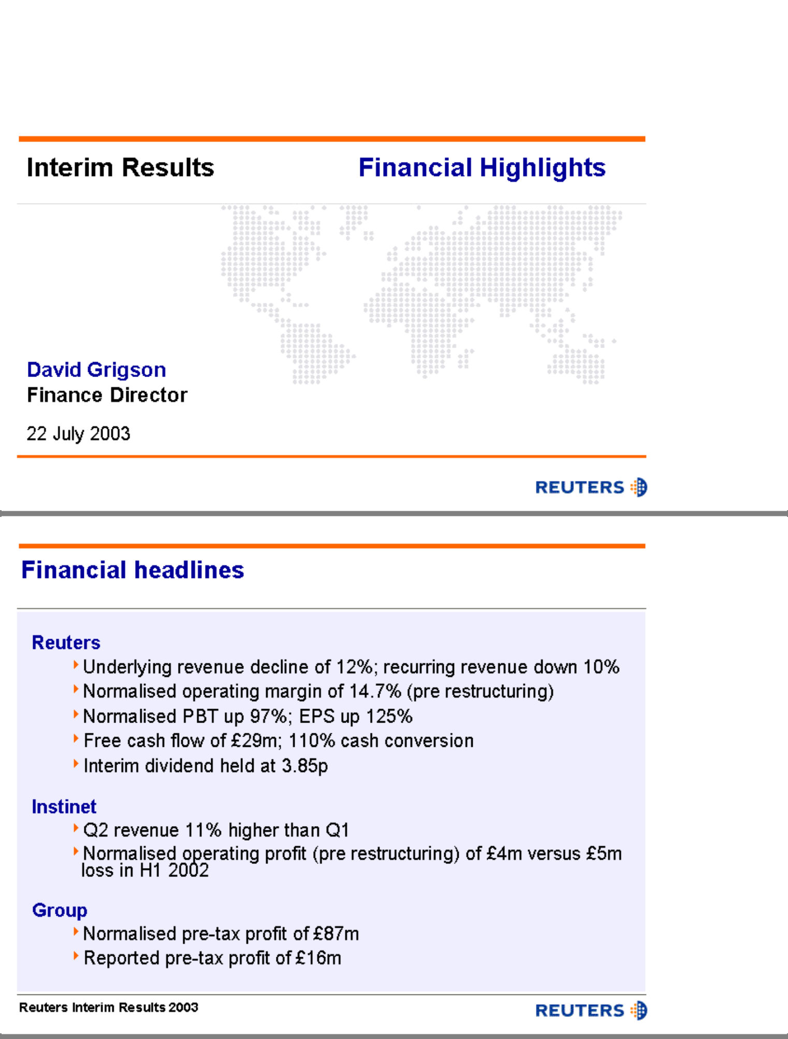

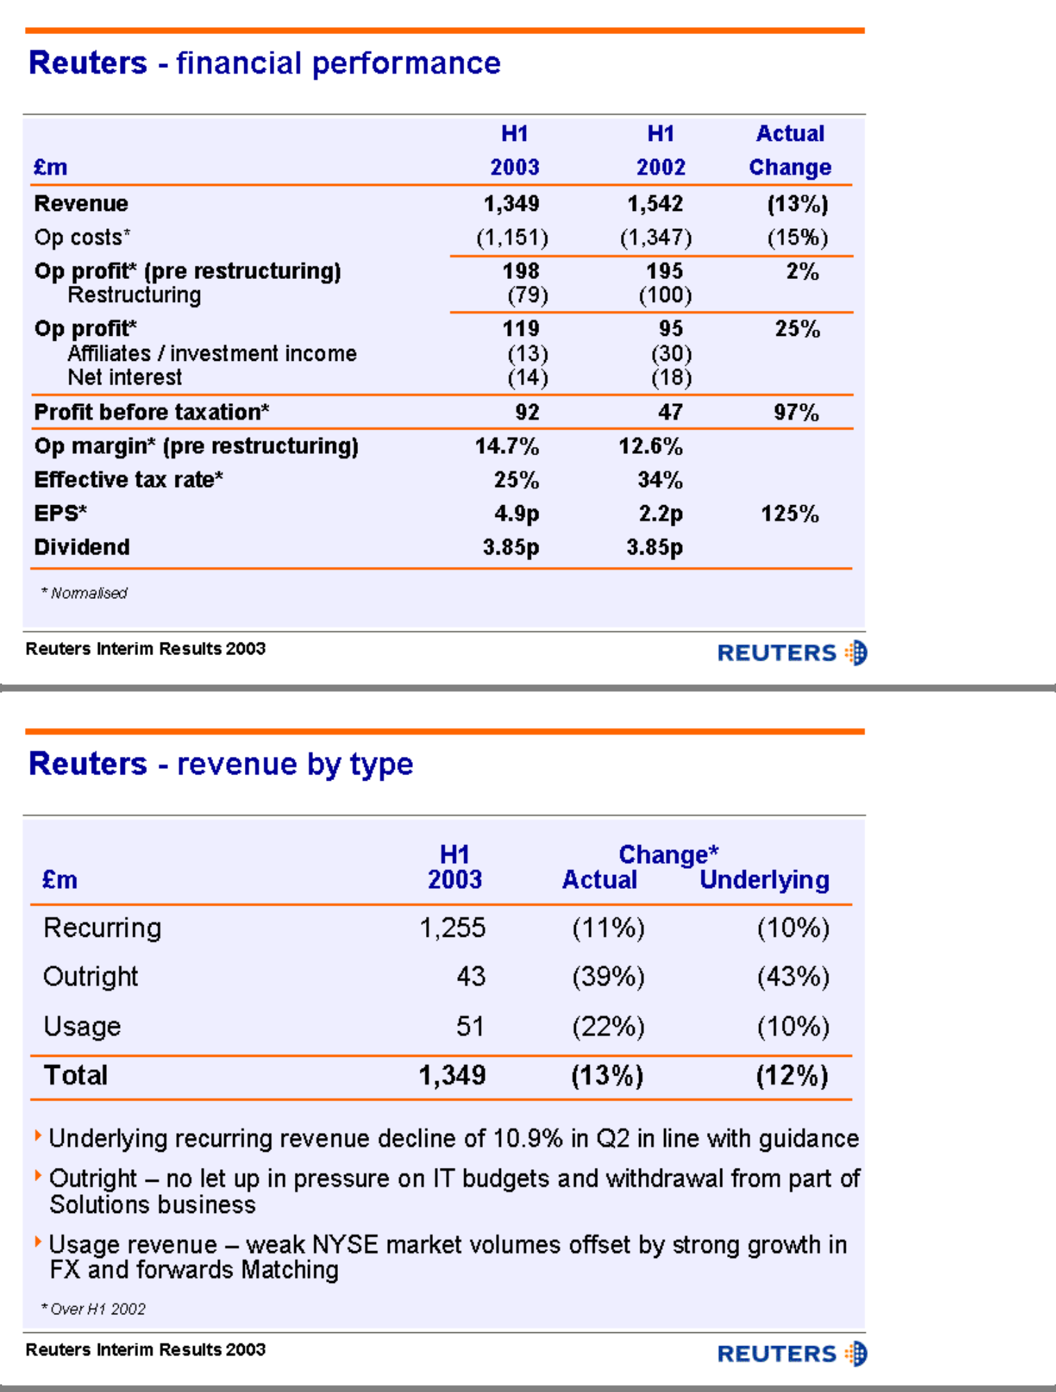

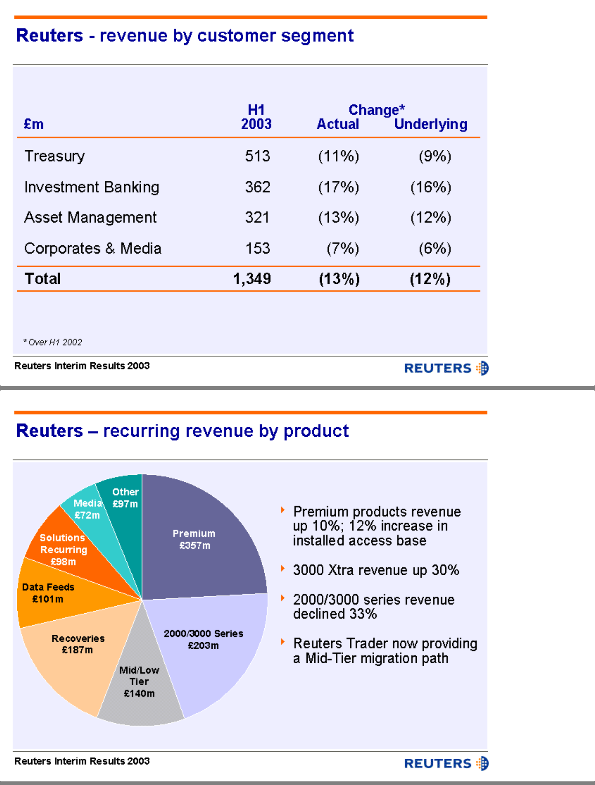

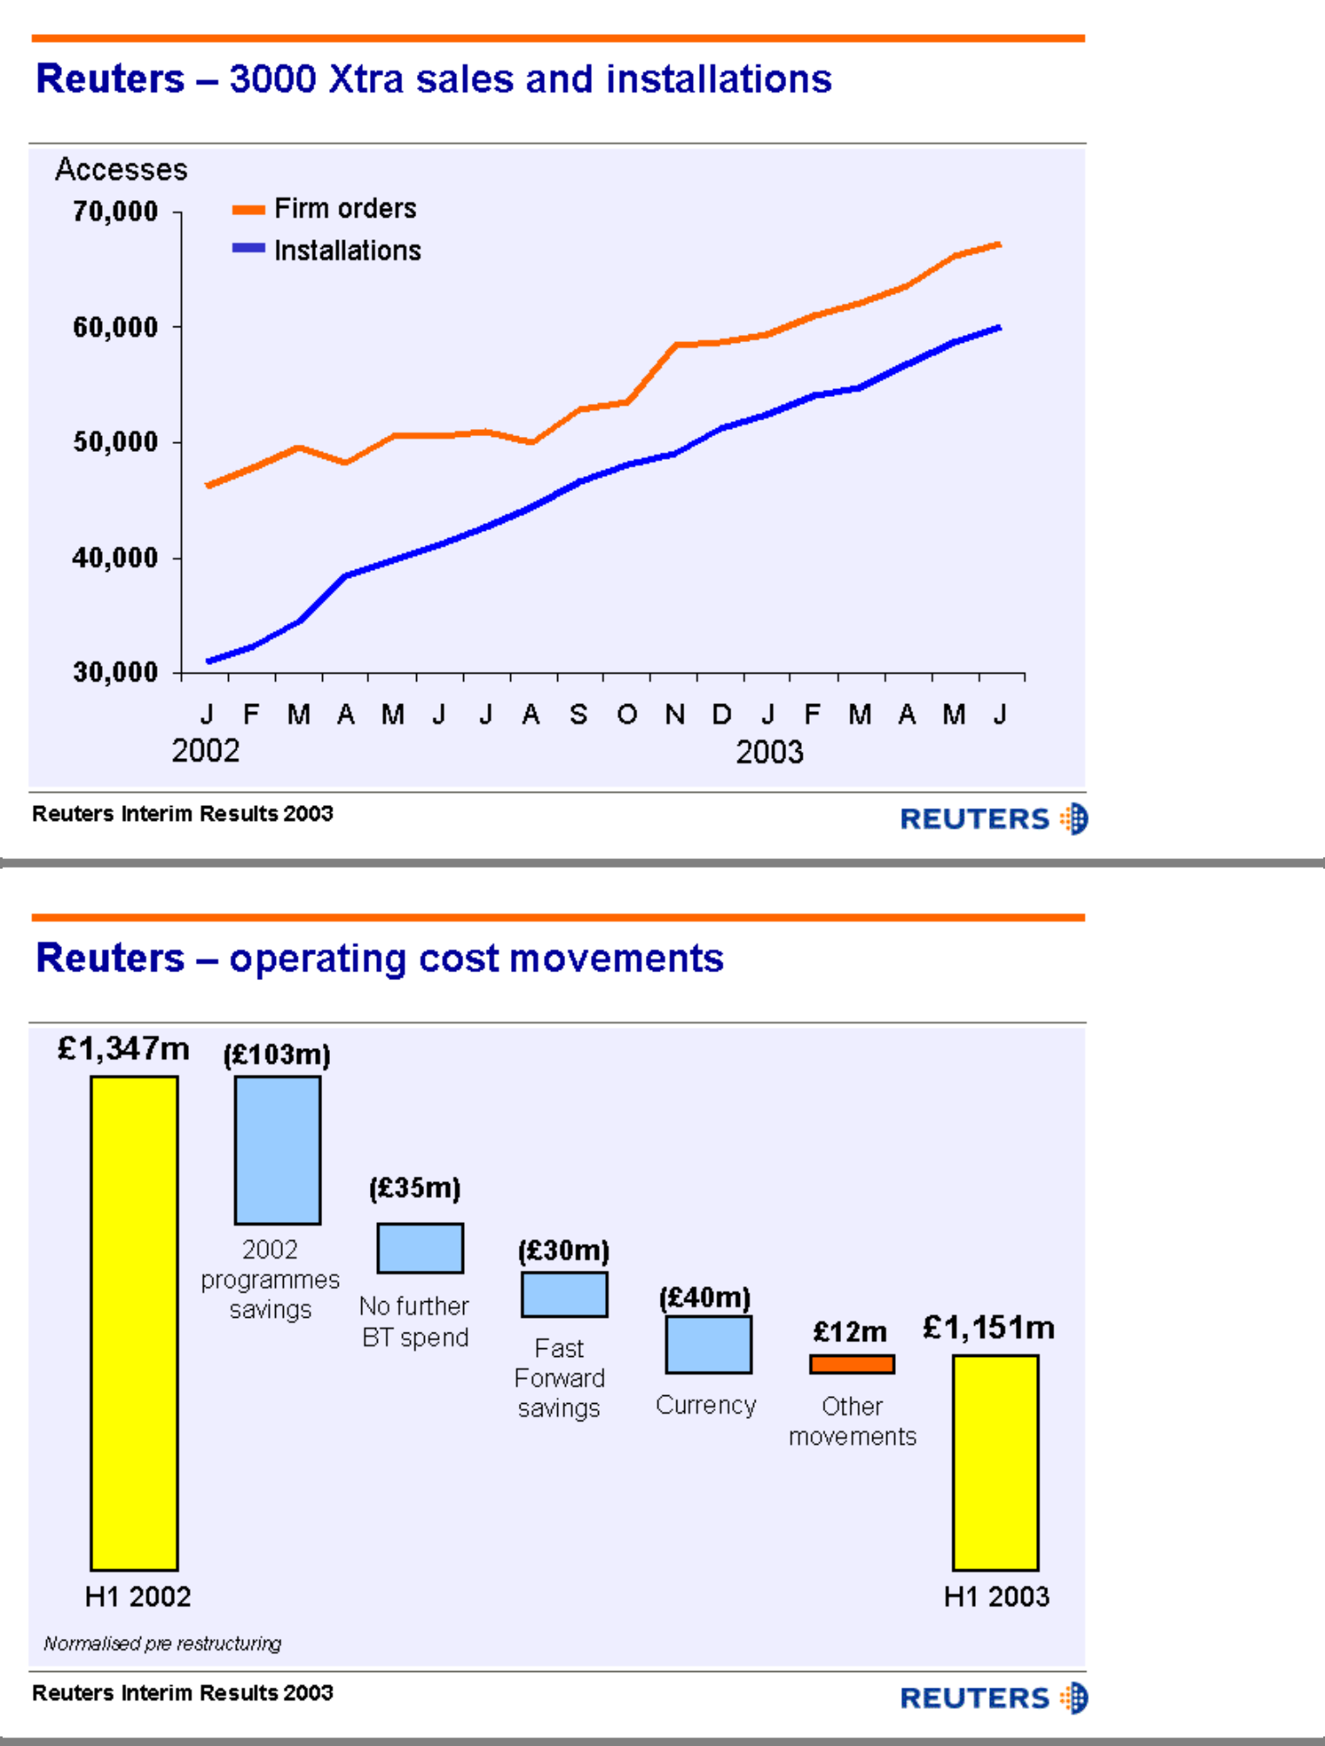

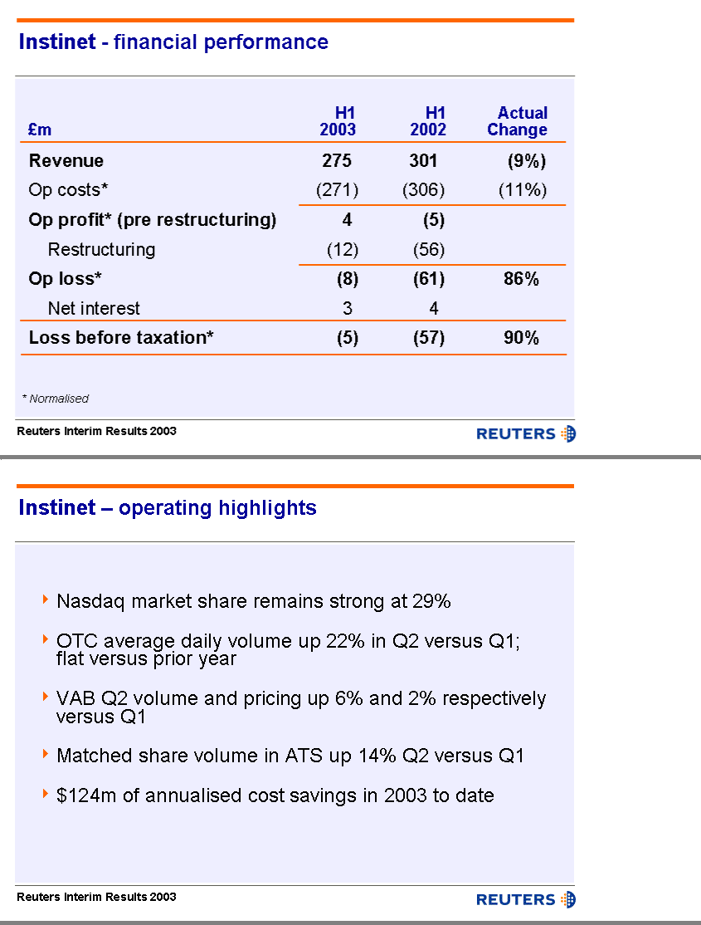

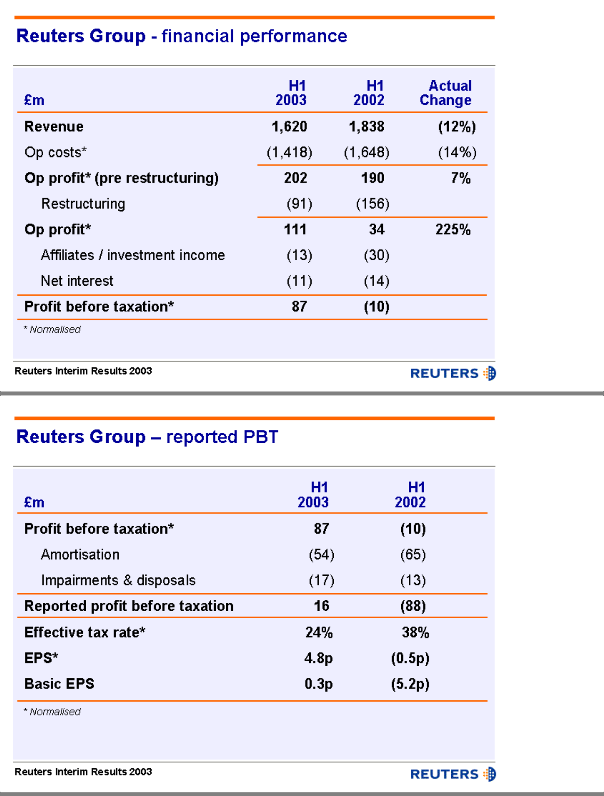

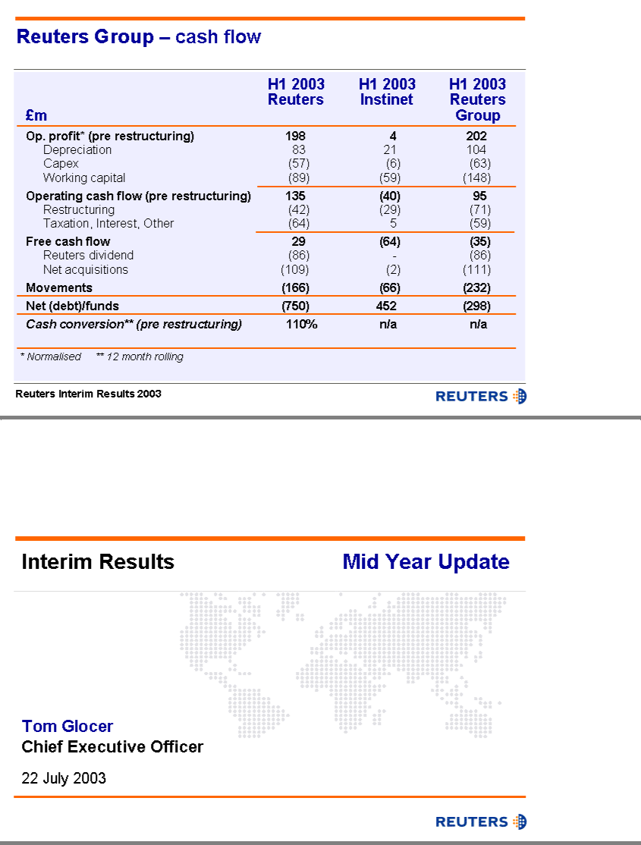

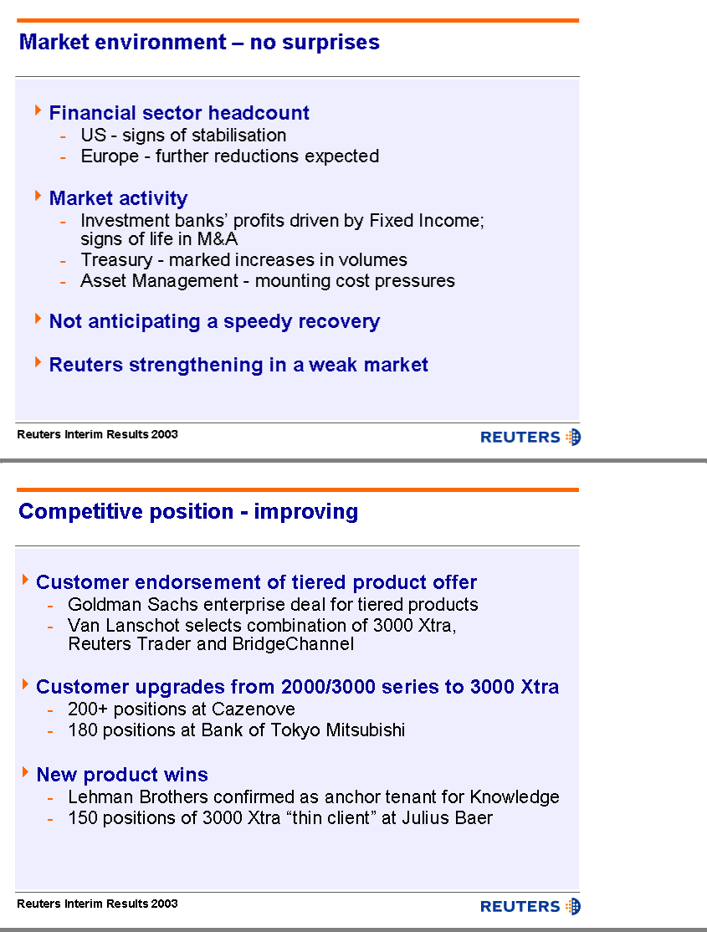

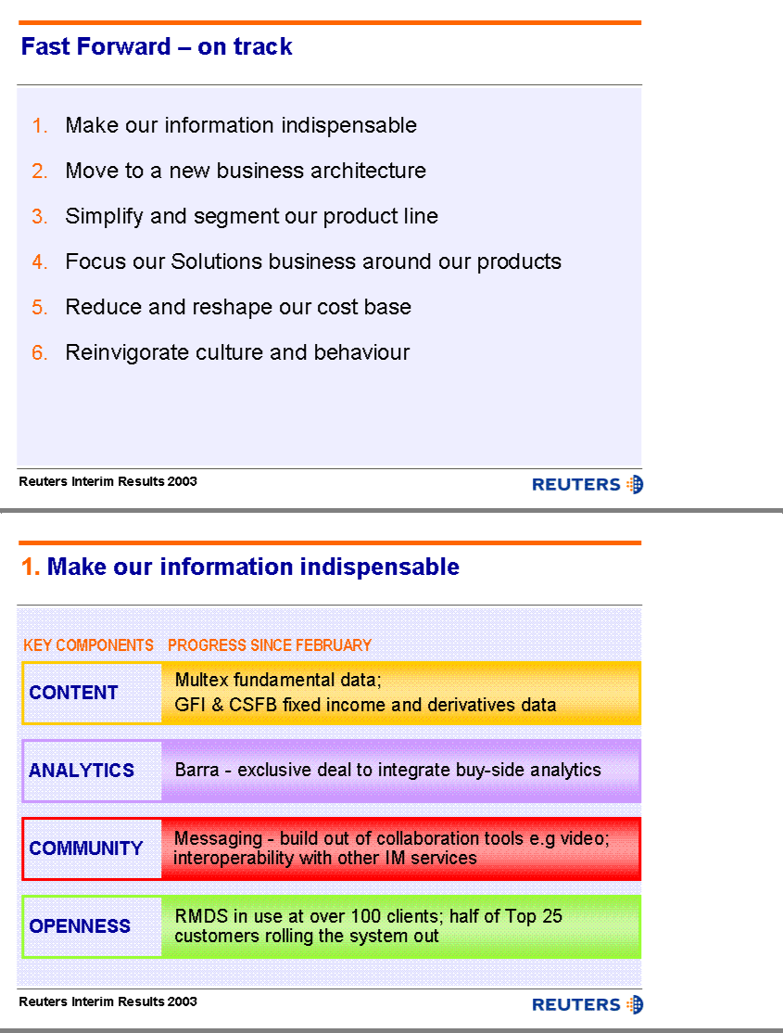

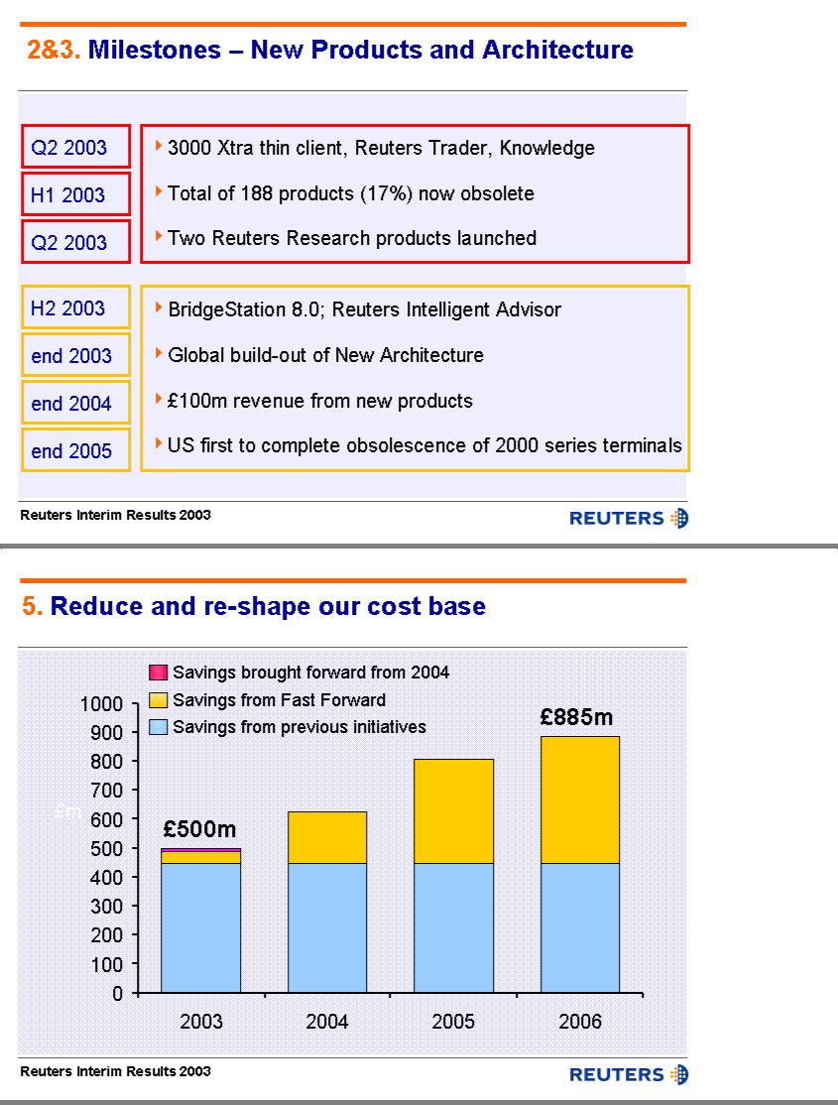

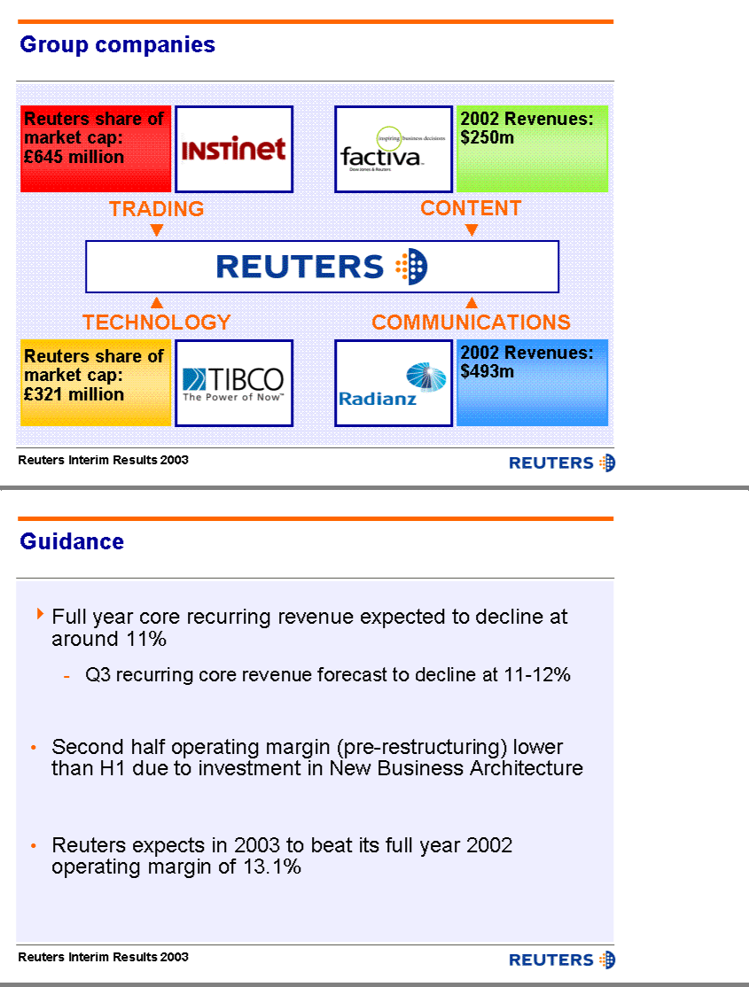

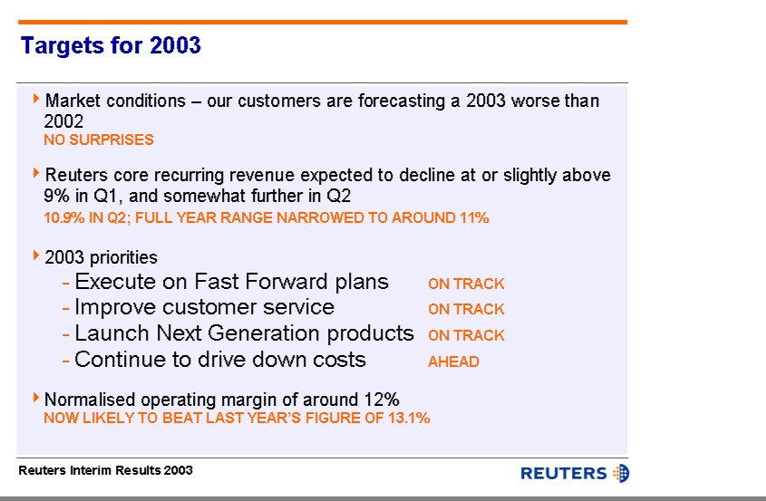

ARCHIVED PRESENTATION

This document may include forward-looking statements. The Risk Factors section of Reuters 2002 Annual Report and Form 20-F describes certain important factors that could cause actual results to differ materially from those in our forward-looking statements today. You can obtain copies of our Annual Report from Reuters website or from our Investor Relations offices in London and New York.

Reuters

Interim Results

London

Tuesday 22 July 2003

Question & Answer Session

Polo Tang (UBS): I have two questions. Coming back to the dividend for the full year, I wondered whether you are still comfortable with that position about maintaining a 10p dividend given that your free cash flow in the first half was £29 million and the full-year dividend is £140 million. On that issue, you may want to talk about where you stand specifically with Instinet in the medium term.

The second question concerns the FX market and whether you are worried about Bloomberg entering that market and also whether you are worried about spin-down to cheaper products from Dealing 3000 to Reuters Dealing Link (RDL) and the impact that that is having on the business.

Tom Glocer: David can start on dividends, I will take FX and spin-down.

David Grigson: I shall take it in two parts. First, let me say that on the dividend, the decision we took and the Board took just a week or so ago, taking into account the cash flow numbers you have seen, our own projections on cash flow and the business, we decided to maintain the dividend at 3.85p. The Board will review the circumstances in February next year and make its decision on the final dividend at that stage and we do not want to pre-empt that discussion or that conclusion.

On the cash flow, the point I made was that there is quite a lot of seasonality in our cash flow. Last year, for instance, our first half free cash flow was £24 million and yet our full-year free cash flow was £214 million, clearly more than enough to cover the dividend. That is not a prediction for this year but it gives an indication of the level of seasonality in our cash flow. We would expect to see a similar level of seasonality this year.

Tom Glocer: On FX, I should be the last person to be complacent about a Bloomberg entry anywhere, but we are doing the right things in the FX world. Later on, you can grab Julie Holland, who runs our Treasury segment and whom I see in the back of the room, but it is a multi-pronged strategy. Dealing 3000 is really a great product if you are trading in the interbank market, and I do not see a combination of Bloomberg and EBS displacing the product that traders prefer to use. We are not sitting on those laurels, we are adding a lot of value to it.

I mentioned in passing the data we are adding from GFI on credit derivatives. That happens to be a growing area where many of our customers are making more of their money than, say, in spot, and we are increasingly offering additional value on the Dealing 3000 terminal and on 3000 Xtra in areas like credit default swap data, FX forwards, options and the like. We have a good game plan and we also have RDL, which is the lighter weight entry product, which to date has done quite a good job fending off EBS. Remember that they have been at it for a couple of years now and have not gained much traction.

On spin-down, this being the question of will the Reuters mid tier and I guess lower tier products steal or cannibalise share aware from the premium products, I would say three things. First, as you see from the numbers that David has gone through, we have continued to add accesses at the premium tier and you can go out and take a look at the thin client version of Xtra 4.5, which is a significant step-up.

Secondly, most of our 3000 Xtra clients are relatively recent. That means they have made a choice over the last 18 months and remember that the Reuters product line has been segmented to date, so people have had a less expensive choice. Thirdly, we have spent a lot of effort in the segmentation process, and you can ask Devin if you have a follow-up question. Take something like Reuters Knowledge: a trader will not trade down from Xtra to Knowledge. It is a very specific tool that is meant to fit into the workflow of somebody in corporate finance.

Polo Tang: If I could ask a follow-up question in terms of spin-down, as I was referring specifically to what is going on in FX, i.e. people spinning down from Dealing 3000 to cheaper products such as Reuters Dealing Link. Are you worried about that trend, do you think that that will subside? If you have a monopoly within the FX market, why did you roll out Reuters Dealing Link?

Tom Glocer: I am a big believer that there is more than one job specification out there in financial services and some people really need a high end, interbank, high velocity product like Dealing 3000, and other people, let us say out in the corporate treasury office or in some emerging markets where they are only trading their currency on a restricted basis, do not need as heavy duty a product. We have not seen a huge penetration, and Julie can probably give us the latest number for RDL if you want. It has been more effective in giving our customers an option so that they know if they want to stay part of the Reuters trading community but do not have really high duty demands, they can take RDL. So far, that has been an option for them for a year now and we have not seen large numbers. We have less than 1,000 RDLs now.

Patrick Kirby (Deutsche Bank): I have a couple of unrelated questions. First, Tom, you have narrowed your recurring revenue guidance to a decline of –11%, which is perhaps slightly more cautious than the upper end of the –10% to –12% that you have been talking about. Could you give us a little more detail about what happened in June, in terms of cancellations, relative to April and May, to make you that little bit more cautious.

My second question is on Radianz. You referred to a revenue base of $550 million, which seems quite a big up-tick on the 2002 number on the slide. The question therefore is, why did the first half losses not reduce by more? Or does that come through in the second half?

Tom Glocer: If you take Radianz, I will talk about the revenue guidance.

As you know, the quarter end months are quite significant for us, because that is when we get in a large amount of variability associated with customers who are on datafeeds and send us back a report about how many they want to leave in place for the next quarter. Last December was a particularly bad month, which hurt us going into this year. June actually was not a bad month — it was better than the number that we were forecasting.

Both David and I are pleased that, in the US, we have now seen a discernable tick-up. We have not seen that at all in Europe and, in fact, in the midst of June, the US out-performed and Europe was a little behind. Until I can actually see a turn in Europe – which I cannot yet see – I am cautious until the end of the year. It could be better but, at this point, I do not see a reason to hang us out on a revenue number.

David Grigson: On the Radianz point, Patrick, the numbers I gave you are right in terms of roughly projected revenue performance for this year versus last year. Radianz is building out its extranet community and, as it does that, it connects new customers to the community. Every time it does that, it takes a new revenue stream but it actually incurs new costs at the same time. If all that ever happened was it just connected customers in an ever-expanding way, it would find that its costs and revenues went up roughly in equilibrium.

What will turn this into a very profitable business is the point at which they start putting new and more services down those connections because there, they start building revenues and high gross margin, because there are very few new incremental costs. So, in the first half, Radianz has been building its revenue growth by adding new connections: over time, it will build its revenue growth by adding new services, and then you will notice that the profit dynamics will change to be more positive.

Vighnesh Padiachy (Goldman Sachs) : I have a quick question on the operating margin with regard to your 13.1% for the full year. I presume that is with the currency benefits you have already seen in the first half. Could you give us some guidance on next year and perhaps just talk through the variables – where you see revenues, inflation, underlying cost inflation, cost savings and so on?

David Grigson: You are right. Assuming that the FX gain that we have taken in the first half will disappear, we are not assuming that we will see a great deal more, because the dollar was already beginning to weaken through the second half of last year and the euro was already beginning to strengthen through the second half of last year, so that effect will start to diminish over time.

We have given you some really good insights into the cost equation in this business. We showed the reconciliations and you can follow through on the Fast Forward savings into every year. You can make an assumption about underlying inflation on our people costs and elsewhere in the business. There are other moving parts, such as our depreciation costs that will be coming down, but we expect our communications costs, as an example, to go up.

We have given you enough to do some pretty sensible modelling – we have been modelling around the cost base. The variable and the margin, of course, is in the revenue line and we have avoided giving you any real guidance on the revenue. In part, this is because you will recall that there can be, as there was last year, some level of seasonality in our sales performance, particularly at the end of last year. Until we come closer to that period, we are not really prepared to leap into the early part of next year and give any guidance for that.

Colin Tennant (Lehman Brothers): Three quick things. First, on the Goldman Sachs contract, could you tell us whether the overall revenue from Goldman Sachs on a like-for-like basis up or down on the basis of this contract? Are you in negotiations with other similar financial institutions, undergoing the same sort of review process?

My second question concerns end-of-day pricing, which you mentioned in the Asset Management segment as an area that has grown. Could you elaborate on your ambitions in that part of the asset management market.

Finally, on the 2002 legacy products that you mentioned, that would be migrated by the end of 2005, what proportion of those 2000 legacy products are in the US?

Tom Glocer: I will ask Devin to help me a little in answering this question. Let me start with Goldman. I expect that it will be positive to our revenues over time and that assumption is based on winning competitively there. A good part of the framework for us is geared around making it easier for them as well as for other customers to make the choice for Reuters. I believe it will be positive.

Second, yes, there are other customers with whom we are now working in this way. It is very time-intensive, because it involves months of work and a desk-by-desk demonstration of why we are feeling confident about our product line, but we are up for it.

I will let Devin add any colour you want on Goldman and answer the end-of-day pricing and where we want to go, that is your baby. In terms of legacy products, do we have a breakdown of the amount of 2000 series in the US?

David Grigson: I do not know exactly what the numbers are from that. I would say that it was reasonably well-proportioned in terms of our overall revenue mix with 25%, roughly, of our recurring revenues in the US – probably that or slightly lower than that, will continue to 25%. We can give you a more accurate number.

Devin Wenig: I do not have a great deal to add on Goldman Sachs, other than to say that this was a very intensive three to four month period of time in which we put our best products in front of non-Reuters users in Goldman Sachs. The agreement we announced today has two components: one is a reaffirmation by Goldman of their relationship with Reuters and the second is a programme that rolls forward, that has in place conversions of other users to Reuters. So this is not a snapshot, it is a progressive programme which will take time and roll forward over the course of the next several months, up to the next year. We are really happy and we believe that Goldman Sachs is really happy.

To answer the question about whether we are doing that with others, absolutely. We have invested a great deal of time in Goldman Sachs and we are very proud of the results and we are now going to do that at other major customers.

End-of-day pricing is a small product line but it is one of our strongest growing product lines through the first half of the year. We are seeing growth across the board in Europe and the US – for a number of reasons in the US, driven by regulatory requirements for the resource pricing, in Europe in part through competitive displacements of others that are in that space. The numbers are relatively limited.

We have just released a fixed income offering in the end-of-day pricing space, as well as several new versions of Datascope, which is our product in that area, and we will continue to invest significantly in that, and see that to continue to grow for us over the course of this year and next.

Meg Geldens (Investec): I was wondering whether you could qualify the picture on all the new client wins that you have announced over the last three or four months. A lot of them are Reuters Plus in the US but I also saw some sort of announcement on 3000 Xtras and Reuters Traders. Can you give us some idea of how many terminals we are talking about and how many of those are substituting or old products versus real net additions to your number of accesses? Also, what is the timing when those are going to be generating revenue? Do they really kick in in 2004? Or is it already happening this year?

Tom Glocer: That is a tough one but I will try. They run the gamut from, say, Lehman Brothers, where Colin may be able to help us more than I can, where it is obviously a brand new product in Reuters Knowledge and we have gone into what we call the early access programme, which is the way we are now developing and releasing products, rather than just spurt them all out. We are working intensively with a smaller group of charter subscribers. So, when will Lehman turn into revenue? It will be the second half of this year. Today, we are getting zero revenues but we will in the second half of the year. Lehman will run, probably, to the entire investment banking department and there are others in the pipeline to follow it.

At the other extreme, you have a seasoned product like Reuters Plus where they generate revenue as soon as they are installed. We tend to track it product by product so it is difficult to cut across but in overall trend, 80% is a replacement of a Reuters product with 20% new but I do expect that to improve. Obviously, at Lehman, none of those were Reuters products before. To the extent that they had products they were all competitor products. At Goldman as well, we have significant upsides so as we branch out with a segmented product line, you will see us occupying more new space so that should improve. All in all, however, if we went back to do it again, the best we could do would be to say that we still think we will do £100 million of revenue from these new products next year. That is about as good a common denominator as I can offer.

Michael Nathanson (Bernstein): I have a follow up on Paddy’s question which was the cost inflation, which is one of the hardest things to track because you keep on producing costs as you go along. I wonder whether one of your biggest categories is your staffing? What is the annual staff increase that you would expect?

Then, for Tom: you mentioned that 20% of 2000/3000 users go to the 3000 Xtra line. Where do the 80% go who don’t go up? The other question for you would be the migration question. One of the worries is as you migrate two types of migrations there is a risk that the barriers to entry that always kept Reuters safe within trading rooms goes away. Can you talk about the barriers to entry changes by migration? Also, how much of the cost saves are depending on full migration by 2006?

David Grigson: I am conscious that a lot of Reuters staff listen into these webcasts so I do not want to say too much about salary inflation other than that it is clearly critical, given that the vast majority of people who work for this company will be here to see Fast Forward through and beyond Fast Forward, for us to take good care of those folk in this environment, which we will continue to do.

The overall inflation component in our first half upward momentum in the cost, because clearly, that is the effect that it has, we estimate at about 2.5%. There are moving parts within that, of which salary is of course one. We are seeing higher rates of inflation in our communications costs than that. We are seeing other reductions in areas like depreciation, as I mentioned. So 2.5% is our best estimate of where the first half was and is probably a reasonable one to use for the balance of this year and into next.

Tom Glocer: I will try to pick up on the other parts of this question, in terms of migration of the 80% that do not go to Xtra or BridgeStation. One challenge in going to customers to date with Xtra that was getting better, is now really good with 4.5.1, was firms think more on an enterprise basis and we did not have a good story, other than, ‘Just please leave it alone, we are working on something for the rest of it’. There were some migrations that went on to Reuters Markets Monitor. Now we have a good answer and a really focused sales message in each of our regions. So in Europe, as the Van Lanschot example gives, we can go in and say, ‘Right, you have 100 positions of 2000; let’s get 35 of them if we can on to Xtra, 50 on to Trader and maybe ten on to BridgeChannel or Reuters Investor’. In Asia, we are going to do the same thing with the new product due out in the first quarter of the year and in the US, we use BridgeStation, which comes in a variety of flavours, or Reuters Plus to do that.

To give a number on it: there may be some loss because when you go to a customer they look at what else is there but so far, it has not been that material in terms of our migration causing a look at someone else. Now, we believe we have a much better package, and in the end we have more control over that.

Your second point was a deep one on whether we were undoing some of the nice barriers to entry we have had from controlling the trading room where we have about 80% of the market. The real issue is where else do they go to? RMDS is a really good product which has a good sales story to people on the technical side and as much as I am trying to simplify Reuters for this audience and other audiences, to consider the information company putting a terminal in front of you, if you want the complexity, we have a room full of people who can give you the complexity about the Reuters data model, the way in which RMDS is multi-threaded so you can have fewer servers on site to run more people, the option we have to run RMDS on Linux which customers have asked for, and we are now starting to put in Linux versions. There is still a lot of that technical gobbledegook which we are good at; we are just trying not to talk so much about it because we have bored you all to tears over the years!

The bottom line, I don’t see that alone changing the picture. It is a struggle for competitors to try and up their game.

The final thing I will say is that we are doing a lot of really innovative work over the whole issue of the Reuters data model, taking advantage of some of the novelties that the Bridge system brings. We think we will be able to up the game in terms of what we bring there.

A final example: with Multex we are now capturing a nice amount of that same lock in by tying together the desk tops that create research, and the desktops that consume it, with a data model and integration into other types of services.

I think less of them as barriers to entry and more as reasons why I must have my Reuters. I think we are adding to those.

The final part of your question – my version is, how much of Fast Forward depends on migration? Migration of RMDS. The answer is nil or very marginal. Migration to the new way to distribute information, yes, more of a dependency? I cannot give you a number. It is less than you might think. Much of this is in our control. What we are trying to do is make this as seamless as possible to the customer, but there is a dependency there. We believe we have been conservative in the way we have approached the phasing of the savings we expect to come to anticipate, as is our experience, that it is one thing for me to say ‘we are moving to a new architecture’; it is quite another to get people to give up products that they often like, or don’t want to spend the money to touch.

Matthew Owen (Morgan Stanley): Can I ask two quick questions, the first on pricing, the second on new products. On pricing if you take revenues per axis as a sort of proxy, you seem to be cutting the prices of the product you want to get people out of, namely 2000/3000, but you also hinted that you were cutting the prices of Reuters 3000. Is there a specific strategy behind this and is it fair to say that you are discounting Reuters 3000 Xtra versus BridgeStation 8.0? That leads me on to my second point which is what will BridgeStation 8.0 be versus Reuters 3000 Xtra: is it the new top tier that you will seek to roll out, does it mean that people are now getting into 3000 Xtra at a point when possibly they will be marketed to something else in a year’s time?

Tom Glocer: Let me start with that one and give David a chance to gather his thoughts on pricing. The strategic future will be a convergence of BridgeStation and 3000 Xtra, and that will not happen for several years. We believe right now that each platform has real value and reflects a slightly different approach to the market. Bridge 8.0 will be without doubt the best workstation you can have if you are trading in US institutional equities. It has all the higher end Instinet functionality, we have improved the data content with a lot of content coming which used to be just from Reuters. 3000 Xtra gets better and better and we are trying to bring them together rather than force it in this generation with a single next generation product which takes out both. That was factored into our Fast Forward migration.

What is more important for us than the container in front of the client is how we achieve commonality on the back end of what feeds it, and there there will be, especially during next year, a great deal of activity in unplugging the historical Reuters feeds and plugging in the new Reuters feeds built on the back of Bridge. It is a somewhat technical subject. There is a series of white papers that we are in the process of doing for clients – three of them are out with another couple to come – so anyone who wants chapter and verse, they are all important issues which our customers care about, and we are trying to be much more front-footed by saying this is what it really looks like. I am sure that Miriam can get the white papers to whomever wants to luxuriate in this information. David, do you want to hit the pricing issue?

David Grigson: What you are looking at is the 9% underlying decline in revenue per access for those mid-tier 2000/3000 series products. I agree it would be somewhat confusing if we reduced the price of those products at the same time as we are trying to encourage migration away. However, the opposite, if anything, is the truth in that we are tactically looking hard at increasing the prices of the products that we would like people to migrate away from, because that adds an element of incentive to it. The reason why that 9% decline is there is simply because of the mix. At the top end of that range, as people migrate up to 3000 Xtra where we have had a product ready to take that migration, the average price of what remains just comes down and that 9% is purely the mix effect of that happening.

Question: Reuters 3000 Xtra?

David Grigson: We discount Reuters 3000 Xtra to people who take high volumes of 3000 Xtra just as we have always done, and what we are seeing is that the average price for 3000 Xtra has come down a little where it is now versus where it was a year ago simply because the volume of 3000 Xtra installed base has gone up. Therefore, there is that trade-off between those two things but nothing beyond that of any material scale.

Jonathan Helliwell (Panmure): In your numbers, how much later do you see Europe slow down versus the US and is that a decent proxy for when we might see it coming out the other end, or do you think the structural differences invalidate that question? Following on from that, Tom mentioned that there are a few more challenging years ahead. Just to check, is that ‘03 and ‘04 or ‘04 and ‘05?

Tom Glocer: That is a good question. First, on Europe we saw that the US business went into the crapper about six to nine months before Europe and it would be very tempting to think, and I am an optimist, that the reason why we have not seen a recovery yet is just that Europe will start to come up in five or six months. My caution comes from the fact that there are enough structural differences. The US is much more aggressive in getting heads out, it is easier to do structurally as we well know from our own efforts. If you look at the downward revisions to GDP that have been going on across the Continent, it does not give a lot of comfort in terms of the vibrancy of the European economies. I do not see the motor that will bring it back in quite the same way.

You are all in a much better position than I to do this and I am looking for a slower and steadier comeback in Europe which pushes us out. As far as how many more years and is it 2003 and 2004, to me it is through the end of next year; 2005 with new products and depending on when Europe comes back could start to be a more interesting year. However, the better time to project that is when we see a change in Europe which we have not seen yet.

Gareth Hunt (Collins Stewart): I have two questions. My first question is on mix and forgive me if I have missed this from other questions. At the end of the period, you had 85,000 accesses in 2000/3000 and you had a monthly rev per access of around £369. My assumption is that all of those 85,000 accesses

will go over the next 18 to 24 months and, if you look at run rates for 3000 Xtra, it seems as though you have done most of the trading up, so these people will be trading down. Can you give us a feel for what will happen to that average revenue number for mid and low tier which is currently £81? Will that continue to move up very aggressively so that that offsets the mixed impact going forward, and could you tell us the phasing of that: is it the second half of this year/first half next, or second half next, if you can?

Secondly, can you comment on unbundling and whether your bulge bracket clients are thinking about this and, if they are not, whether you think they should

be?

Tom Glocer: I would not be so sure that in terms of the 2000/3000 population there isn’t still a good reservoir of people who are willing to trade up to Xtra. We have seen that now at Goldman Sachs, for example, which is certainly not a laggard when it comes to looking at their information needs. We are also now able with the thin client version of 3000 Xtra to go to smaller firms to whom we have been unable to offer an economic way to move to Xtra from 2000 without rolling in the lorry with all the trading room systems formerly needed to run Xtra. Despite the fact that numerically in terms of how much money people are paying on the 2000/3000 series there is a wider gap as we have creamed some of the top of that series, there are functional reasons why we think we should be able to mine it. The number I have given you of 20% remains our best because of those and other factors, and we believe that a bulk of the others will move over either to BridgeStation, to Trader or the new Asian product, or go to a segment. For example, some of them will move to Reuters Intelligent Advisor, some will move to Knowledge as they have been misplaced before.

In terms of the soft commissioning issue, we are watching the issue very closely. We noted that the response date for submissions in response to the discussion draft has been slipped now to October by the FSA. I do not want to read too much into it but they are obviously concerned about the issue that it would not be brilliant for London as a capital of finance to see all of the activity move offshore if other markets were not as quick to ban softing. In the US we see much more of an expectation that it will generate more transparency of which we are all in favour as opposed to any sort of ban on softing.

If I could give you a number on it, because the UK situation seemed closer at hand, we calculated how much of our revenue in the UK we get on a softed basis, whether it is via a contract whereby a sell-side firm pays for a buy-sider’s service, and that number was £13 million per year. Therefore, firstly, it is not enormous and, secondly, we would expect to keep a fair amount of that because these are not people who just have it for no reason. Thirdly, it is at least questionable how aggressive the move to ban softing will now be.

David Mercurio (GSIC): I have a qualitative question, related to the competitive issues. In the past, we have seen the competition being differentiated on several parts – the product part, the pricing issues and lastly the service issues. You have talked a great deal today about the product side and the tiering side, and we take the view that Reuters is getting traction on that side, but we have not really discussed the service side.

If we can use, say, the Goldman new win as an example, how much money will you be showing, or can you give us a sense of what metrics, if you can? How much resource would you be showing at the Goldman side to make sure that you win the contract, but you keep the contract going forward? Maybe metrics in terms of the amount of people you have hired on the service side? Or the number of people you have changed on the service side. It would be a real pity to get the traction but then not execute on the service side. I know that this is rather a qualitative issue, but I would like to understand how that works.

Tom Glocer: You are dead right. Everything we are doing on the product side comes to nought if we do not surround it with a better customer service experience. We do two things there. First, we measure what we believe is the leading indicator, which we call the ‘great service index’ internally. This measures everything from the number of calls to the helpdesk to the amount of time to resolve calls, the up-time of the various networks and the reliability, and so on.

That internal index has ticked up every single month this year and it is showing a nice trend. The issue that is ultimately the most important, however, is whether that will come through in terms of a customer perception that the service is changing? On an anecdotal basis, I am beginning to hear good feedback there. On a structured, numeric basis, we have not yet seen an up-tick in our customer satisfaction number which we run, but I am becoming optimistic that we will.

The final point I would add, will be to give you a few more numbers. We added a couple of hundred trainers last year and we are continuing to add trainers, while headcount is going down, so we are obviously doing even more on a gross basis. That is really important because, as long as we have sophisticated products like 3000 Xtra, we have to take up the training game and not go the other way.

The other piece of it, though, is just making the products easier to use. If you play with Reuters Knowledge or Trader (I have never had a minute of training on either -you see one of our major cost savings!) you will see they are much easier to use as products without training. That will help us, in effect, to shift resource to Xtra and BridgeStation and away from products which, basically, service themselves.

Jeff Meys (UBS): I have two questions, one on RMDS. You answered the question about migration and the barriers to entry, but there is also another issue there. If you open up your platform, it also offers other companies the opportunity to piggy-back on your platform. How do you see that with the clients you have migrated from RMDS? Has Thomson gained more foothold into those clients? Is there any experience you could share with us?

My second question concerns pricing on the Treasury products. You had a 9% decline in recurring revenue, and we know that RDL has an impact but it is only a very small number of terminals in that space. What is happening to pricing, especially at the top end? Is there any pressure on that side?

Tom Glocer: I will let David jump in on pricing.

In RMDS, first, Thomson does not have a datafeed product. Secondly, they do not have a data model – a sophisticated way of saying that this is where you can expect to find, in the way I present data, this particular part rather than some other. If you are writing applications for data, you need to know with certainly not only the quality of the data but the format in which it comes.

Finally, RMDS, in terms of openness, does not do anything that Triarch and TIB have not done for the last 20 years. If they had a datafeed, they would have been able to interface with those. We have a commitment to openness all along. Is there anything in the pricing data?

David Grigson: I gave you a number in my presentation which was that, across the entire dealing community, obviously Dealing 3000 has the majority of accesses there, and then a growing number of RDL – 430 units as at the end of June. The pricing across the whole community has come down a couple of per cent. The principal reason for that is because of that trade-down effect of Dealing 3000 coming down a little, and the higher numbers of lower priced RDL, but that is the principle. Within the Dealing 3000 community, there is no price pressure.

Mark Braley (Cazenove): Just following on from David’s question on service, to pick up the other parts of your holy trinity of the turnaround content, it seems to me as an actual user that there is more content there all the time, which is great, but our bill is not going up, week on week.

Tom Glocer: David Mayhew, perhaps we can do something about that!

Mark Braley: How does this impact the margins in the long run? If you look at 3000 Xtra in content terms, it is getting closer to Bloomberg, progressively. Presumably, Reuters Trader will be closer to where 3000 Xtra was envisaged to be two years ago. Could you just talk around the content implications?

Tom Glocer: We think we are taking up our game on those series of things – content, analytics, community and openness. Sometimes that takes the form of, say, an acquisition like Multex where, from a margins perspective, it is neutral, but we are obviously using capital to do that and we are very sensitive about that.

Other times, let us say with the innovative deal that Jane Platt here in the front row included with Barra, it is more by way of a marketing relationship. There is revenue sharing and actually some revenue increase, so that tends to be margin-friendly. There is some content that is just so good that it is worth paying extra for it. We are pretty good at making sure that we only go for that content which actually can either increase the price point, i.e., you are going to trade up to a bigger terminal because you now want that, or it will increase the volume.

We are not seeing significant margin erosion from the additons we are making. From here on out, I do not think that will be the major factor. Was there a second part to your question?

Mark Braley: A have a very quick, completely unrelated question on occupancy, which I think was down 15% year-on-year. Presumably, that moves in a relatively lumpy fashion. Should we expect any further big step-change in that in future years?

David Grigson: Yes, it moves in a lumpy fashion but what moves it is low numbers of people to house. We still have a fair way to go in reducing the headcount numbers to the 13,000 that we planned for the end of Fast Forward. You should expect to see some low levels of occupancy, even from these levels over the next couple of years. But you are right – we tend to move out of whole buildings, as opposed to floor by floor, and therefore it tends to have a slightly lumpy effect. You saw the 15% decrease in occupancy costs versus an 11% movement in staff costs, and those things really ought to be moving pretty well in train.

Patrick Wellington (Citigroup): I have some very simple questions on revenue and costs. The first one, on revenue, is that I seem to remember that there was a moment when the second quarter was going to be the low point for organic reccurring revenue growth, and it looks as though that is now shifting out to the third quarter, or even the fourth quarter. I would really like an underlying feel for what might have changed there, or the extent to which you are simply being deliberately bearish in your assumptions. You must know what the lag effect of last year’s cancellations were, because there do not appear to have been a load of job cuts this year.

The second question is on cost savings. You saved £30 million in the first half but it will only be £55 million for the year, which suggests a degree of re-investment. Tom has talked about re-investing in the past. To what extent is the £440 million of net cost savings sacrosanct, or additional to profitability, and to what extent might you continue to re-invest it in new product, new structures and whatever, as we go forward?

Tom Glocer: What is sacrosanct is the delivery of that number as a firm commitment and we will not let up the pressure on that. This is a multi-year plan and so it is difficult for me to sit here today and say that, if there is a fabulous investment opportunity in 12 months, we should not do it, or that we would have to be forced to do it another way. Nothing has changed since February, certainly, in our view of having to invest more or less, and yes, the second half of the year reflects investment in essentially the P&L effect of building the Fast Forward architecture.

In terms of the revenue, I do not remember signalling a second quarter trough. David and I still feel that, in terms of our net sales, the fourth quarter of last year is the low point. That has been held up, certainly through the first two quarters this year. The key issue is, what will the fourth quarter this year look like? I will give you my version of guidance: I am expecting it to be better than the fourth quarter last year but one reason why we are not giving you guidance into next year is because we would like to see how much better it actually is. That would imply, on the revenue side, certainly a bottoming at some point in the second half of the year.

That's it. Thank you very much indeed.

— End of Meeting —

ARCHIVED PRESENTATION

This presentation may include forward-looking statements. The Risk Factors section of Reuters 2002 Annual Report and Form 20-F describes certain important factors that could cause actual results to differ materially from those in our forward-looking statements today. You can obtain copies of our Annual Report from Reuters website or from our Investor Relations offices in London and New York.

REUTERS GROUP PLC

INTERIM RESULTS

Tuesday, 22 July 2003

US CONFERENCE CALL

Nancy Bobrowitz: Good morning to the US and good afternoon to the UK. I am from Reuters Corporate Communications. With me here in London are our CEO Tom Glocer, Finance Director David Grigson and Miriam Mackay, who heads up our Global Investor Relations. We did a presentation for investors here in London earlier today and you can see the full set of slides from that meeting on our website along with the press release and webcast, audio replays as well as the transcript, so there is a full record of that meeting. Rather than go through that presentation in full, Tom will run through some highlights and then we will go straight over to your questions. Before we do so, we would like to remind you that these presentations may include forward-looking statements and actual results

could differ materially. Our interim results press release issued today and our 20F list the risk factors that could cause results to differ from our forward-looking statement. See our website for copies of both of those documents, or you can get them from our Investor Relations Offices. Now over to you, Tom.

Tom Glocer: Thank you, Nancy. For those of you who did not get up early either to watch the webcast or have seen it since, I shall give a shorter version. However, if you have already heard this, bear with me four or five minutes.

We issued a solid set of results this morning in line or ahead of expectations. Our revenues were in line with expectations and we have narrowed our guidance for recurring revenue for the full year to a decline of around 11%. Our operating margins came in ahead of our full year guidance thanks to discipline in managing our cost base, so we came in at 14.7% in terms of margins in the first half versus a full year guidance of 12%, and there was also some currency movement at play which was favourable to us. We now expect to beat our last year full year margin of 13.1% in the year ending 31 December 2003. Just to give you a little more flavour there, we do not expect in the second half of this year to see quite as strong a margin as we saw on the first half, because we will be spending a little more under our Fast Forward programme to build out our architecture. So the range is somewhere between 13.1% and what we just came in with which is 14.7%.

I shall focus on three other topics in this call. The first is the market environment in which we are operating, the second is Reuters competitive position and, thirdly, where we are and where we are going on our Fast Forward programme.

First, let me talk about the market environment. There really have not been any great surprises this year, which is what has helped us to deliver at or ahead of guidance. Conversations with our customers and our own analysis suggest that, while the bulk of industry headcount reductions are probably through in the US, there is a little more to go in Europe. From a market perspective, we are also seeing a mixed picture. Fixed income continues to be the main driver of profits in the investment banking sector, but there are also some early signs of life in M&A activity. Treasury volumes are showing a marked increase but falling profits in asset management are resulting in significant cost pressure. For Reuters, this means that we are not expecting a speedy recovery. We see another two challenging years ahead of us but we believe that we are taking the right steps in our product line to participate fully when markets strengthen. The bottom line is that any progress Reuters makes in the near term will continue to come from us taking up our own game.

Now let me move on to competitive position. Despite this trading environment which continues to be difficult, we have really improved our offering in the first half of the year, which is showing through in a good list of sales wins this quarter. In particular, we are seeing three distinct trends which emerge. First, we are starting to see customers endorsing our tiered product offer. On this, I point to an innovative project we have undertaken with Goldman Sachs that has been talked about in the media over the weekend. Over the past several months, we and Goldman have jointly conducted a firm-wide analysis of their content and workflow requirements and the vendors who could satisfy these exacting demands. Goldman has now signed an enterprise-wide deal with us that simplifies our offer to them into three tiers of products, reaffirms Reuters as the principal product for several thousand users and creates a framework for others to swap over. It is significant as a deal because it is not so long ago that many of you worried that a competitive review like this carried major risks for Reuters. Now, our product line is coming together in such a way that there is more opportunity for Reuters than risk at a firm like Goldman.

The second emerging trend that I point to are clients that are upgrading from our legacy products to 3000 Xtra. From what we have seen so far, it looks as though some 20% of the old 2000/3000 users are trading up to Xtra. We have had good sales in the quarter to Cazenove and Bank of Tokyo Mitsubishi. Those two we can mention by name; others are bound by confidentiality agreements.

The third trend to flag is the take up of our new products, where I am happy to confirm today that Lehman Brothers has agreed to be the anchor tenant for our new Reuters Knowledge product. They will be rolling that out to all their senior bankers.

Fast Forward – on track

With that, I will turn to Fast Forward. One of the key strands of Fast Forward is about reinvigorating the firm’s culture and behaviours, which has a vital link to our ongoing programme to improve customer service. There is still a way to go here but we have begun to make some progress.

Make our information indispensable

We continue to invest in Rich content and analytics to improve the competitiveness of our products. You already know about our Multex acquisition and what we are doing with that in our product line. We are now also building up our fixed income offer, with recent agreements to add data and analytics from CSFB and credit default swaps data and analytics from GFI, which is the leading inter dealer broker in that market. We have a lot of room left to grow in fixed income, starting as we are from a smaller relative share.

In analytics, we signed an exclusive alliance with Barra, the leading provider of buy-side analytics and, during the second half of the year, we will be integrating Barra analytics into our buy-side products. We continue to lead the way on what we call ‘openness’ – the ability for clients to work freely with our data and incorporate it into the way they work. Our next generation market data system, RMDS, is now in use at over 100 clients and half of our Top 25 accounts are in process of rolling out the system.

Milestones – New Products and Architecture

What I would like to do next is to set out for you the key milestones in our move towards the new business architecture and a fully segmented product line, which form the core of our strategy under Fast Forward. In the first half, we met our commitment to strengthen our product line with the use of three new products: 3000 Xtra in a thin client version, Reuters Trader and Reuters Knowledge, all now out with clients. We have been equally active in clearing out some of the legacy dead wood in our product line. We have made obsolete 188 products and are now on track to remove a further 136 by the end of this year. The integration of Multex is progressing well and we have launched two new research products since the acquisition. We are now expecting that the normalised PBT coming from Multex integration will be closer to £3 million negative this year than the £10 million negative that we forecast at the time of the acquisition in February.

Looking forward to our second half, we are expecting to introduce a new version of BridgeStation in the US – version 8.0 which comes in the third quarter – and that is notable because we have incorporated much of the high end functionality from the old Instinet and analytics product line. This is quite exciting in equity markets and will come out in the third quarter. In the four quarter, we are finally going to roll out Reuters Intelligent Advisor, aimed at the private wealth management market. Overall, we are on track to generate £100 million in revenues from our new products in 2004.

By the end of this year, we expect our full new architecture to be ready for use around the world and, in the first quarter of 2004, we will be deploying products that are built from scratch on the new architecture. To give you an idea of migration timing, the first area where we expect to complete the migration from older, 2000 series products, is in the US, where we plan to make obsolete the terminal versions of the 2000 series by the end of 2005.

Reduce and re-shape our cost base

I will now move on to touch briefly on costs, which continues to be a very good story for us. I said back in February that we would spend about £160 million of the Fast Forward charge in 2003 and that we would see savings of some £45 million this year, on top of the £445 million that we were already expecting from our prior initiatives. I am pleased to say that we are staying well ahead on costs. In the first half, we have already achieved two thirds of this year’s £45 million, and we now also expect to bring forward £10 million of savings that were originally scheduled for next year, taking this year’s total under Fast Forward to £55 million in savings.

We are in line with our expectations on the phasing of the charge. We spent £79 million in the first half. Severance has accounted for \bout 70% of the spend to date and most of the rest relates to costs incurred as we consolidate our office space in Europe and the US.

Guidance

Next, I have an update on how we view our prospects for the full year. Despite the recent improvement in market sentiment, we remain relatively cautious about our sales prospects through the remainder of this year, particularly in Europe. We expect the underlying decline in third quarter revenue to be between 11% and 12% and for the full year decline to be around 11%.

Second half operating margin, always on a pre-restructuring basis, is likely to be lower than the 14.7% we achieved in the first half of the year: this, as I mentioned, is because of the planned increase in spending on Fast Forward. Nevertheless, we now expect to beat our 2002 full year operating margin of 13.1%.

To finish up, I would say that we are making good progress against our plan and our short-term forecasts are either unchanged or improved. Nevertheless, I would caution you against forecasting too early a recovery here. We set out Fast Forward as a three-year programme for a good reason. We still have a long way to go but I am very confident that we are on the right track.

With that, I will hand back to Nancy. David Grigson and I would be more than happy to take questions.

Questions & Answers

Drew Borst (Bernstein): I wonder if you could help me to understand the margin guidance a little better because I am a little confused. We are talking about normalised margins, which are before any of the Fast Forward restructuring charges and yet we are talking about the reasons why you see margins in the second half following on from the first half being because of Fast Forward spending. I thought we were talking about margins excluding those charges. Could you explain that a little?

Secondly, I noticed the impact that foreign currency had on your cost base. It was a pretty substantial benefit – looking at the reduction in the cost base, it came down by £196 million, of which £40 million was from foreign currency. What kind of assumptions are you making regarding foreign currency for the second half and full year, as related to the margin guidance?

David Grigson: Let me pick up on both those points. First of all, I would just draw a distinction around Fast Forward investment between the severance costs related to headcount reduction, which is clearly a significant part of where the savings are coming from. You are right – we have put that on the restructuring line and you are right that we do not count it in our margin calculations. I would draw a distinction between those costs and what we call ‘above the line’ investment in building up a new business architecture, in building out the new development centres, particularly the one in Bangkok, which we need to start up before we start to make closures of development centres elsewhere.

We counted that as revenue or cost investment, operating cost investment, rather than restructuring. Therefore, the savings numbers that we have talked about today – the £55 million is a net number of those types of investment. We are therefore distinguishing between the restructuring costs, which are very much one-off in nature, related specifically to headcount reductions and then lower real-estate costs associated with lower occupancy, from the cost that flows through the business as a consequence of dedicating additional resource – some of it consultant resource, and some of it contractor resource – to help us on special projects associated with building out the architecture.

Drew Borst: Are you guys putting any numbers around that?

David Grigson: Yes. Very quickly, the gross savings in the £55 million is just over £80 million, and the investment going back in above in the operating costs line is about £25 million.

Drew Borst: That is for this year?

David Grigson: That is for this year.

Drew Borst: Is there more spending next year as well, in addition to that £25 million?

David Grigson: It will be pretty well front-end loaded, because it is important to build out the architecture before we start the migration of new products onto it, which is where many of the savings will start to come from. It is important to build out the new development centre before we start to migrate some of the activities that are taking place in other development centres to that. This cost will be front-end loaded in the plan.

Drew Borst: OK.

David Grigson: On the currency issue, yes, you saw a significant benefit to the cost number, principally because of the weaker dollar. This was not quite an equal and opposite, but there was at least some offset in the ready number as well, because 40%-ish of our revenues are US dollar denominated and we saw an impact there. That was a little over £20 million and the net effect, some £18 million of improvement, fell through to the operating profit line which, once you analyse that number, actually has more to do with the fact that our profits are made in euros, and it was the strong euro that was the principal contributor at that level.

You are right – our first half margin did benefit to the tune of about 1% as a result of those currency movements. We have not assumed, at least in contemplating our own guidance, that there would be much more currency impact to go for the second half. In part, this is because the US dollar was already showing signs of weakening at this time last year and through the second half of last year, and similarly the euro was showing signs of strengthening through the second half of last year. Therefore, those currency effects will begin to diminish to zero anyway.

Drew Borst: Fair enough. Thank you.

Mark Braley (Cazenove): I have just a couple of follow-ups from this morning. In the meeting this morning, Tom, you made some comments about either the net sales trends in the business improving in the fourth quarter or the revenue trend improving in the fourth quarter. Can you clarify precisely what you were saying there and to which level of guidance it applied?

Tom Glocer: My expectation is that our net sales in the fourth quarter of this year will be better than our net sales were in the fourth quarter last year.

At the moment, I have to restrict myself to only a hope that the revenues would be but I was referring this morning to the net sales number.

Mark Braley: Presumably, you are still assuming that global net sales in the fourth quarter would still be negative and, hence, you would still be working on a negative run rate of revenues into the early part of 2004 at least?

Tom Glocer: I am an optimist but not enough of an optimist to believe that Europe will turn and we could be positive there in the fourth quarter.

Mark Braley: Thank you. I have an unrelated follow-up as I have to ask a question about Messaging. You are at about 40,000 active users now with about 20,000 of those outside of the group. Is this something you will put a number on in terms of a target for six months’ time or a year’s time? How business critical is this to get the installed base and the usage levels up?

Tom Glocer: It is quite important. We now have a series of internal targets and it has been run in quite a disciplined way. The real challenge that we are focused on is the marketing effort. The basic technology is there and we are doing two things on the systems front. One is that we are expanding it from pure text to what we call collaboration, so video, white-boarding, there are some interesting applications that one can share back and forth, and that is well in train. That just adds more value to Messaging. The other is inter-operability. We do not need to go out and win, we are not charging our clients for this. With our Messaging on everyone’s desk, what we need to do is commoditise Messaging so that it just becomes part of the functionality that everyone has, and we believe that that is definitely an achievable goal, though it will take a couple of years to get there. That is the marching order for David Gurle who runs that group and I believe he has a good strategy together to do it.

Mark Braley: Picking up on the interoperability point, as and when Bloomberg’s true Instant Messaging appears, presumably you will be pretty keen for your messaging to be interoperable with theirs but they may be less keen to reciprocate – would that be a fair characterisation?

Tom Glocer: We have not discussed it because they have not introduced their IM component yet, but they are not the only ones out there with whom it would be interesting to inter-operate. If you go around to financial institutions, you see plenty of MSN, Yahoo, AOL, so we believe there is opportunity there. To me messaging will not be some special thing where the financial services world has its own deeply proprietary version and the rest of the world is on standards. It will go standards-based and that is why we are in the right place and we believe that time is on our side.

Mark Braley: I have just one more unrelated question. As far as the products that you have obsoleted this year in the first half and that you are intending to obsolete over the rest of the year, so the 118 and the 136 products, presumably the revenue base there is very small? Presumably, you started with the smallest products first, so can you put a number on that?

Tom Glocer: I cannot do so now but we will go off and get you a number on it. Much of them are domestic products where every country manager in Reuters went off and had its own domestic flavour, which put significant strain on development, support and so on. Therefore, one of the reasons we started with a lot of smaller ones is not only because we have been waiting to have the new architecture but also from a load factor, many of those smaller ones nonetheless eat up a lot of resources, which, as you know, we are reducing and it is one of the ways in which we are able to reduce staff.

Mark Braley: That is great, thank you.

Jeff Fan (UBS, Canada): Can you talk a bit about the process in respect of building out the new architecture? And the implications that might have on the total costs of ownership for your customers on the new products and new applications? Also, on the costs of perhaps supporting those products as you roll those out in 2004 and beyond?

Tom Glocer: A very broad question but a very good one; I will tackle it piece by piece, then if you want more, come back for it. There are significant potential savings for customers in the following respect. Equity data is growing at a logarithmic rate as a result of things like decimalisation of the US equity markets, fragmentation of markets, so you get multiple quoted options and so on, and auto quoting, where a change now in a decimal of an underlying US security causes a ripple effect as the multiple quoted options all have to re-price, driven by a machine. That is creating an anomaly for many clients who are seeing the money they are making, the profitability of equity trading, go down while they have to scale up all their systems – their coms, their servers, their PCs, to handle that onslaught.

The first area that we are building out in the new architecture is taking the existing, very capable and advanced Bridge system and building out its equity handling capability so that it will become the prime handler, at the end of this year, of equities data. By doing that we are expecting to be able to switch clients who are running applications on the more traditional IDN network over to that new network and thereby help them either to reduce their costs or at least to stop them having to invest a lot more. That is one of the pull factors.

In addition, as I go over to some of our new products – take Reuters Knowledge or even thin client Xtra – there has traditionally been a fair amount of overhead associated with the heavy on site kit that you have had to have to run Reuters systems. We are now making them run in a much lighter way, so 3000 Xtra in a thin client you do not need any kit on site; it is all up at the head end. For Reuters Knowledge you have a choice: some folks’ bigger installation like Lehman Brothers I would expect to take advantage of their on site Reuters infrastructure. Smaller firms can just take it hosted by us, which cuts down, for the smaller folk in particular, on the amount of overhead.

Switching finally to answer the cost side on Reuters, we also expect to be able to save – and it is part of Fast Forward saving – in that we currently have not only just the Reuters in the Bridge version but we probably also have 10 to 20 different networks, often supporting domestic products, which are carrying similar types of data and all updating. The move to a single product architecture is so that we only have to carry the data once, we only have to support it once, we only have to come out if we have a new application, a new version, new applets, say. We do not do it ten times over, we just do it once. I am not doing justice to everything else but rather than bore everyone on this call, I will stop there and if you want more, I am happy to give it.

— End —

